WESTERN AUSTRALIA SELF FUNDED RETIREES Inc.
wasfrinc@gmail.com
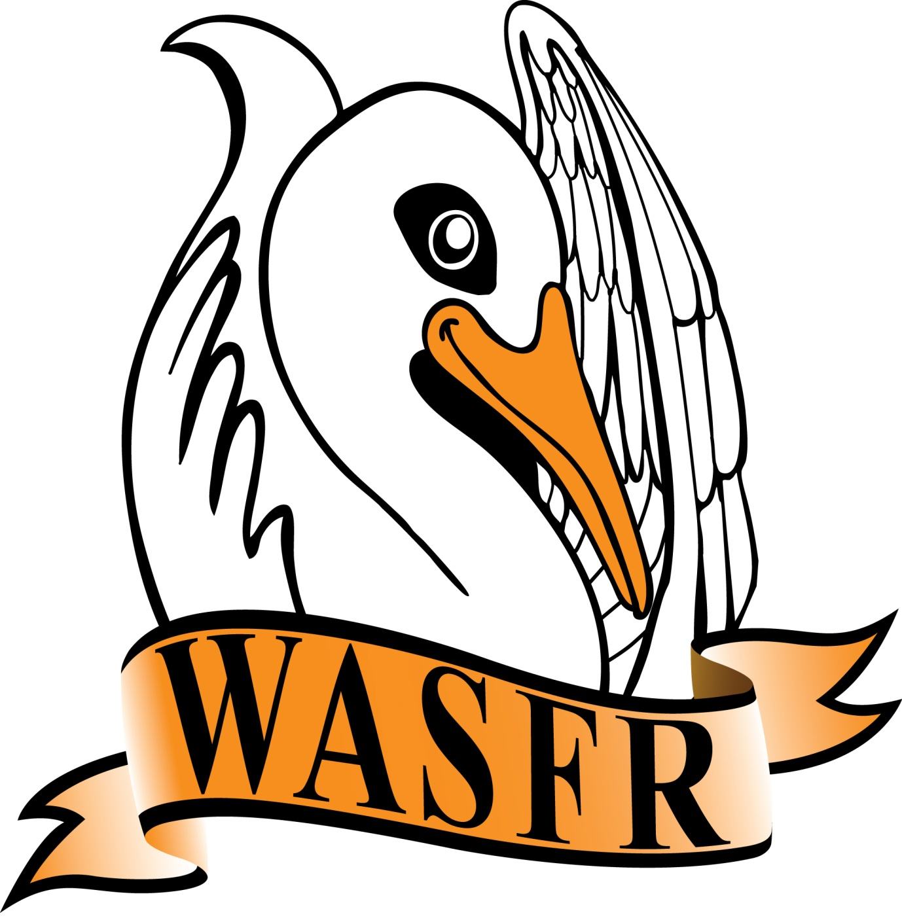
MINUTES
Minutes of the General Meeting of WASFR Inc. held at the Cambridge Bowling Club, Howtree Place, Floreat, on Friday 12 JULY 2019.

The President opened the meeting at 10am with an attendance of 52 members and 28 visitors. A warm welcome was extended to the visitors. The President asked everyone to be aware of others when asking questions of the guest speakers we have today. Issues surrounding the NBN can be quite complex, and it is not possible for everyone to spend a lengthy amount of time attempting to resolve any potential personal problems during the 1 hr. presentation. The 2 speakers will be available after the close of this meeting.

APOLOGIES:
C. Atkinson, P. Farr, D. Brooke, G. English, L. & E. Thompson, J. Yeatman, W. Cann

CONFIRMATION OF MINUTES:
Moved S. Yeates, seconded I. Moller, that the Minutes of the meeting held on 14 June 2019 be accepted as a true record. Carried.

BUSINESS ARISING:
WA Seniors Alliance: The President said that we continue to carry on although 2 organisations (National Seniors and COTA), are in doubt as to their future membership. National Seniors have difficulty in accepting the wishes of others in relation to the aggregration of Land Tax. We hope that this matter can be resolved in the next few months. COTA WA has a new CEO who has asked for some “time out” while she comes to grips with a few issues - she also wishes to review COTA’s priorities before committing to future membership. In the absence of any other nominations, R. de Gruchy was re-elected as Chair, and Michael Cain was re-elected as Secretary (there is no Treasurer).
Some thought has been given to the 2020/21 State submission - we are waiting for a few details on several items. Any suggestions would be welcomed.
Alliance for a Fairer Retirement System (AFRS): This group of 11 different organisations continues to concern themselves with issues surrounding retirement. At one stage, it was thought that once the problem with franking credits was finalised, that the group might disband. However, there does exist a desire to see what benefits a group of like-minded organisations might be able to achieve. The phone hook-ups are now every 4 weeks. At the last call (3rd July), the final draft of a letter to the Federal Treasurer was agreed to. This letter calls for the government to follow through with earlier promises to hold a Retirement Income Review which will include the age pension, the superannuation system, and private savings with emphasis on the adequacy, sustainability, certainty and fairness of those arrangements. A few points that were mentioned are (a) How can the retirement system ensure incentives are in place to encourage those who can save for an independent retirement to do so, and (b) What is an adequate level of retirement income commensurate with their pre-retirement standard of living that older Australians should be seeking to attain. There is also the matter of “Are there gaps, or issues, which indicate a lack of fairness in terms of either horizontal or vertical equity for current or future retirees.” The issue of Deeming Rates will also be an item on the agenda.
......./2
State & Federal Advocates for Fully and Partly Self Funded Retirees
CORRESPONDENCE:
- Emails (many) from the Royal Commission into Aged Care
- Email re Draft Strategy - Elder Abuse in WA
- Email re power-point presentation from Andrew Mckay
- Emails re articles for WASFR News - July edition
- Emails re the AFRS draft submission (Review of superannuation, taxation etc.)
- also phone hook-up on 3 July 2019
- Emails re Cambridge Seniors “What’s On” list (calendars etc.)
- Emails re withholding tax (NAB)
- Emails re WA Seniors Alliance - National Seniors continuation (?)
- Email from Greg Hunt - funding for hospitals etc.
- Email from ASA - request to circulate to members
- Email from the ATO - information for members
- Email from Rice Warner (increasing the SGL to 12%)
- Gold Coast Retirees - July newsletter
- SuperGuide 2018/2019 year
- COTA Connections June 2019
- also publicity re the Care & Ageing Expo on 3rd & 4th August
- ACOSS media releases (including possible future tax cuts)
- CPSA “The Voice” July 2019
- Letter from Bank of Queensland (Term Deposit due)

FINANCE: M. Harris referred to the Finance statement on the reverse of today’s Agenda which showed the total funds available as at 30 June 2019 totalled $7739.73. There were no questions from members.
M. Harris reminded members that annual subscriptions are now due (1 July 2019).

GENERAL BUSINESS:
Other: The President reminded members that our AGM will be held next month and encouraged everyone to consider nominating for a position on the Committee. Unfortunately, one of our most valued Committee members will not be re-nominating and we are taking steps to fill that vacancy.

There being no other General Business the meeting closed at 10.40am. After the morning tea break, the President introduced Brent Fleeton and Ashley Merrett from the NBN organisation here in WA. They presented a very interesting power-point presentation and answered a myriad of questions relating to converting from the current ADSL system to the new NBN. Both Brett and Ashley stayed back after the meeting closed in order to give further assistance to members.

Speakers for the following months are as follows

9 August Samantha Spiro Mercy Care - Stay at Home as Long as Possible
13 September Anne Williams How to Travel Light
11 October Dr. David Thorne Palliative Care
8 November Christmas Party no guest speaker

Confirmed .........................................

Date ..................................................

NEXT GENERAL MEETING: FRIDAY 9 AUGUST 2019

WASFR Inc. does not give advice on any personal, or financial, matters.
Nothing written or spoken in the course of WASFR meetings, talks or publications,
is to be construed as advice given to members.
State & Federal Advocates for Fully and Partly Self Funded Retirees

