WESTERN AUSTRALIA SELF FUNDED RETIREES Inc.
wasfrinc@gmail.com
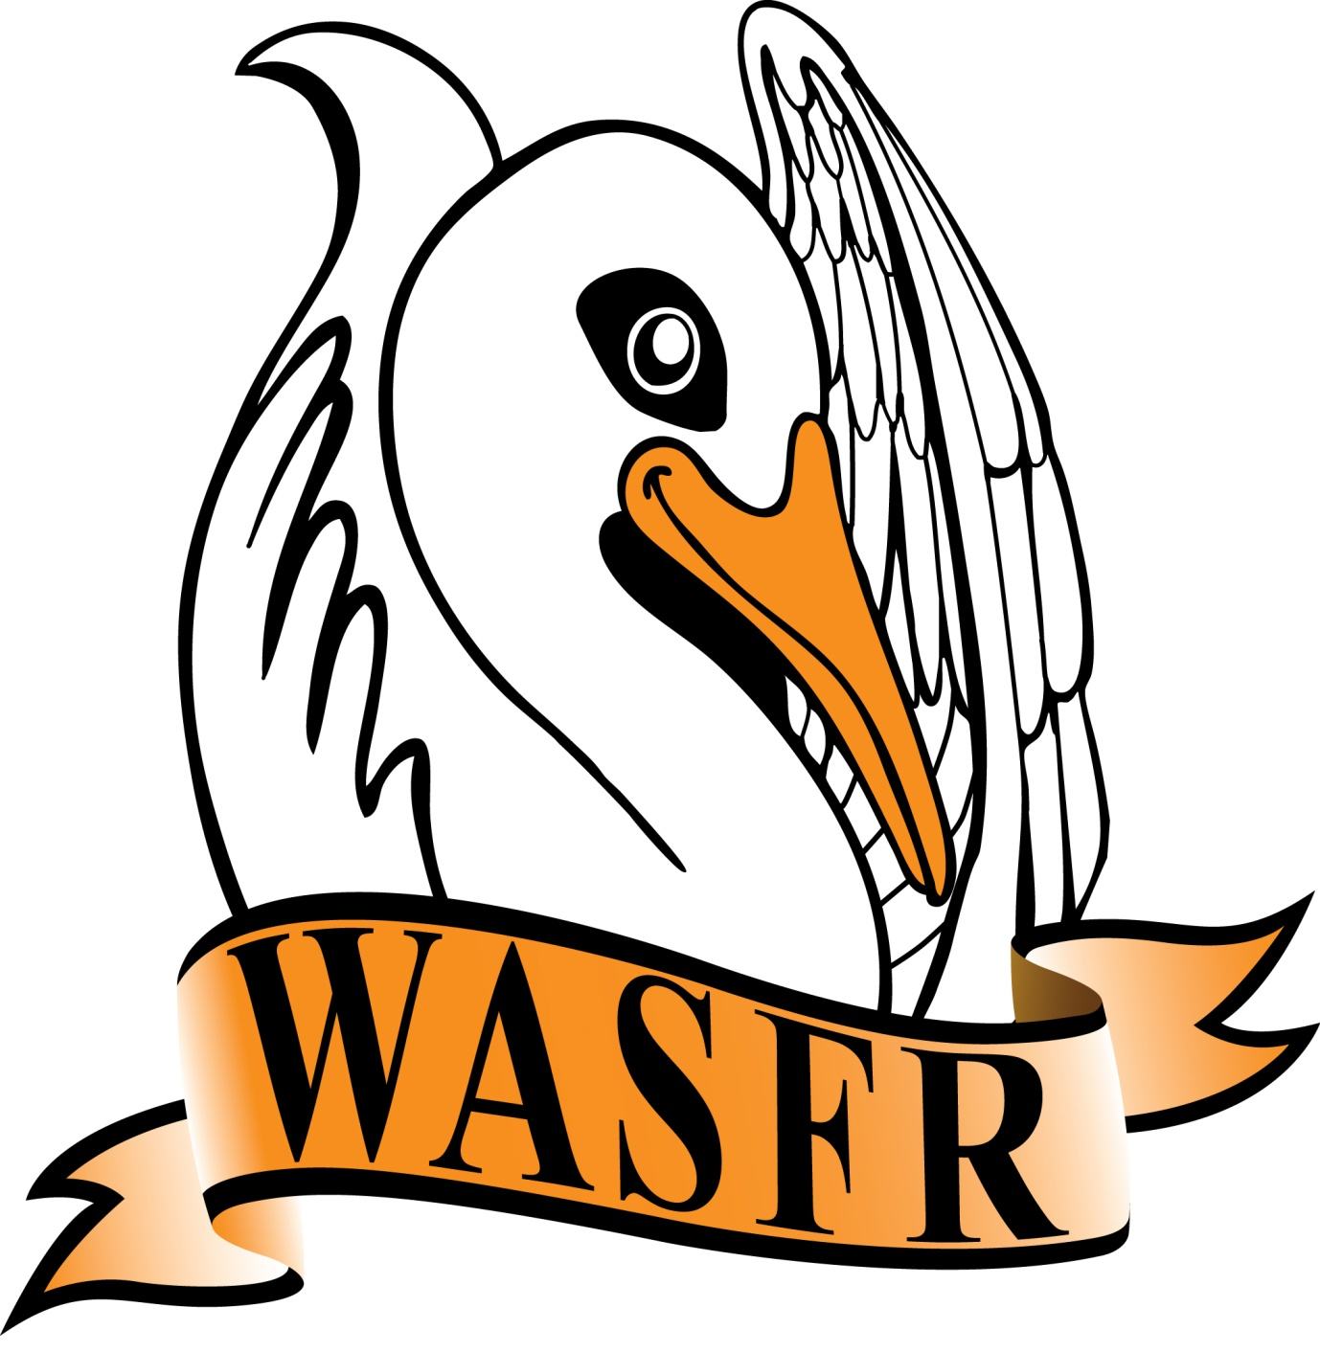 MINUTES
Minutes of the General Meeting of WASFR Inc. held at the Cambridge Bowling Club, Howtree Place, Floreat, on Friday 13 SEPTEMBER 2019.

The President opened the meeting at 10.05am with an attendance of 32 members and 15 visitors. A warm welcome was extended to the visitors. The President reminded everyone that WASFR was mainly about improving the concessions available to retirees, and was not involved in social outings etc.

APOLOGIES:
C. Atkinson, W. Cann, J. Yeatman, L. Halvorson, H. Ellis.

CONFIRMATION OF MINUTES:
Moved B. Arnold, seconded I. Moller, that the Minutes of the meeting held on 9 August 2019 be accepted as a true record. Carried.

BUSINESS ARISING:
WA Seniors Alliance: The President said that there was little to add to what has already been reported at earlier meetings. The next meeting is scheduled for October/November and we are hoping that the issue with National Seniors can be resolved. It is too soon to expect that COTA WA will be in a position to confirm their involvement with WASA - the new CEO did ask for a period of 6 – 8 months before being in a position to decide if they wished to continue with their membership. The President invited everyone present to contact one of the Committee if they had any particular items that might be suitable for inclusion in the 2020/21 State submission (which should be completed by the end of November).

Alliance for a Fairer Retirement System (AFRS): The last telephone hook-up of this group of different organisations took place on Wednesday 28th August. The main topic of discussion was the 40 page report from the Actuaries Institute (August 2019). This report had 3 authors (who were all highly respected financial managers), but had no real substantive recommendations. The report clearly stated that it was “not a blueprint for retirement provisions”, but was intended to raise discussion, and ask questions, on a number of topics that seemed to warrant attention. It covered items such as the Age pension (deeming rates, income and assets tests, inclusion (?) of the family home, age eligibility, taxation anomalies etc.), the number of retirees who are/would be still in rental accommodation, life expectancy, costs of Aged Care, the superannuation guarantee levy, possibility of a universal pensioner concession card, refundable accommodation deposits (RADs) and the possibility of death duties. One of the authors (David Knox, a Senior Partner from Mercer Australia), was present at the meeting and spent the major part of the meeting explaining the points raised in the report. Many questions were raised but the final analysis was that the government, in conjunction with other organisations, need to start considering how all these, and other, issues can be addressed. The possibility of a governmental “Review into Retirement” provisions is a good way to start - but there is no current indication just when such a review will commence.
A summary of the 40 page report was circulated amongst members, as was a copy of WASFR’s response to the AFRS (forwarded after consideration by the Committee). General discussion followed. Everyone was reminded that this response was just one of several that will be discussed at the next meeting of the AFRS (25th September). Of major concern was the possibility of the family home being included in the Assets test for the Age pension. Note: Several prominent organisations had expressed the belief that, eventually, the value of the family home (above a certain limit), should be included in the Assets test.
The comment was made that the costs, and governance, of Aged Care establishments should not be overlooked. The President agreed and expressed the view that the current enquiry into Aged Care should be the beginning of improvements in this area. State & Federal Advocates for Fully and Partly Self Funded Retirees ........./2
BUSINESS ARISING: cont.
Interview with Anthony Spagnolo: The President said that he had an interview scheduled for 19th July with Senator Mathias Cormann but was told at the last minute that the Senator was unavailable. Instead, one of the Senator’s senior advisors (Anthony Spagnolo), made himself available for an interview. The interview with Mr. Spagnolo lasted for well over one hour and covered a number of different topics. There were some issues e.g. Deeming rates, indexation of CSS and PSS pensions, that were not accepted by Mr. Spagnolo but he did agree to discuss these with his colleagues when he returned to Canberra. So far, there has not been any feedback from Canberra and the President said that he would follow this up in the next few weeks. The President has been promised a meeting with Senator Cormann when is possible.
CORRESPONDENCE: -
- Emails (many) from the Royal Commission into Aged Care
- Email re Pensioner free travel changes (now need to apply)
- Email re National Scam Awareness week
- Email from Ken Wyatt re Stronger Communities Programme
- Email to Vince Connelly re Care Home collapse (RADs)
- Email re A.I.R. Forum on 10 September 2019 (in Perth - the President attended)
- Emails re TV interviews (I. Henschke) - Deeming Rates & Mortgage debt
- Emails re Review of Retirement Incomes (David Knox, Grattan, Rice Warner)
- Emails from AFRS - phone hook-up 28 August 2019
- Email re new Committee members
- Email re submission of form to Dept. of Consumer Affairs
- Email to COTA - Deeming Rates
- Arthritis & Osteoporosis - September newsletter
- COTA Connections August 2019
- CPSA The Voice - September 2019
- Gold Coast Retirees - September newsletter
- SuperGuide August 2019 newsletter

FINANCE: M. Harris referred to the Finance statement on the reverse of today’s Agenda which showed the total funds available as at 6th September amounted to $8,690.18. There were no questions from members.

GENERAL BUSINESS:
Other: The President said that WASFR now only has 5 Committee members (which includes the President, Secretary and the Treasurer). This is considered to be quite low and we all need to think about what might happen if this trend continued. We need more volunteers to be on the Committee.
The President reminded members that the 2020/21 Federal Pre-Budget submission should be finalised shortly and invited everyone to advise the Committee if there were any issues that should be included.

After the morning tea break, the President introduced Anne Williams who proceeded to discuss the many issues involved in “travelling lightly”. Anne is involved in organising travel for seniors (overseas as well as within Australia), and was able to show how it is possible to pack the minimum amount of clothing and still be comfortable. The issue of travel insurance for those over 75, and 80, was raised by several members.
Speakers for the following months are as follows

11 October Dr. David Thorne Palliative Care
8 November Christmas Party no guest speaker

Confirmed .........................................
Date ..................................................

NEXT GENERAL MEETING: FRIDAY 11 OCTOBER 2019

WASFR Inc. does not give advice on any personal, or financial, matters.
Nothing written or spoken in the course of WASFR meetings, talks or publications,
Is to be construed as advice given to members. State & Federal Advocates for Fully and Partly Self Funded Retirees

