WA Seniors Alliance

Submission to WA State Government

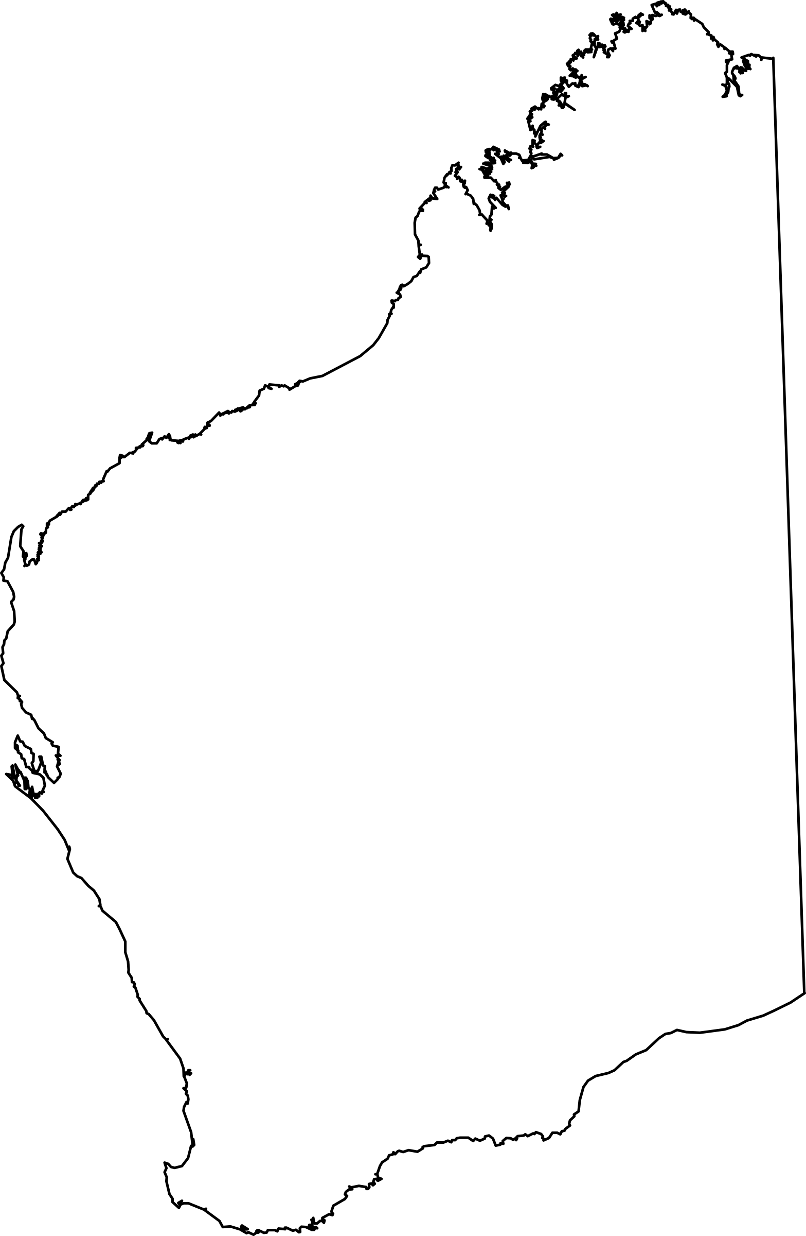
January 2020






BACKGROUND

The WA Seniors Alliance was formed in February 2018. It was originally known as the WA Seniors Consultative Forum which was formed in August 2008 following a meeting of like-minded Seniors organisations, who have a common interest to protect their living standards from both State and Federal Governments. The intention in forming this group was to be able to provide a focused approach on Seniors’ interests. In many cases, each of the nominated Seniors’ organisations have a particular emphasis placed on certain issues that may be confined to those members of that particular organisation. This is a fact that cannot be denied. However, it is also true that there are several issues that are common to each and every Seniors’ organisation. It is on these particular issues that this submission is focused.

It is worth repeating that similar bodies exist in several other States in Australia. There is an obvious benefit in various organisations all joining together to make a consolidated approach to Governments.

The organisations involved in this group are

Association of Independent Retirees (A.I.R) Ltd. (A.I.R. WA)
Australian Pensioners & Superannuants League WA Inc. (APSL)
Naval Association (WA Branch) (Navy)
Returned & Services League of Australia WA Branch Incorporated (RSL)
Superannuated Commonwealth Officers Association WA Inc. (SCOAWA)
Western Australia Self Funded Retirees Inc. (WASFR)

27 January 2020

SUMMARY OF RECOMMENDATIONS

A summary of the recommendations in this submission from the WA Seniors Alliance is set out below. We ask for your support in consideration of these issues.

RECOMMENDATION No. 1
That consideration be given to the (once only), conditional waiver of Stamp Duty on the purchase of a place of residence by a Senior, who has reached pensionable age, and is in possession of either one of the Pensioner Concession Cards, a Commonwealth Seniors Health Card or a Department of Veterans Affairs Gold Card.

RECOMMENDATION No.2
That the WA State Government extend the times for free travel on public transport, for WA Seniors, Aged and Disability Support Pension cardholders, Monday to Friday, to commence at 8.30am for zones 5 to 9, in lieu of commencing at 9am (as at present).

RECOMMENDATION No. 3
That all existing Aged Care facilities be fitted with automatic fire sprinklers before 2022. In order to facilitate this request a low interest loan should be made available where required.

RECOMMENDATION No. 4
That a review of Land Tax collections in WA be carried out with the intention being to abolish the policy of aggregation of the values of different parcels of land when calculating the rate of Land Tax that is to be paid. Such review to be limited to those WA residents in possession of a WA State Seniors Card.

Attached is the rationale for the above requests.
For enquiries contact:
R. de Gruchy
phone: 9447 1313
email: rdegruchy@bigpond.com

RECOMMENDATION No. 1
CONDITIONAL WAIVER OF STAMP DUTY ON THE PURCHASE OF A PLACE OF
RESIDENCE BY A SENIOR.
Following retirement, and the consequent significant change of lifestyle, many Seniors find it
desirable, or necessary, to depart from the family home and obtain alternative accommodation
This may, possibly, be closer to medical and hospital services, and may also be more suited
to their changed physical circumstances and lifestyle. To assist this process, we request a
waiver of Stamp Duty, following the sale of the family home and the purchase of alternative
accommodation providing
- the Senior is of, or above, “pensionable age”, and
- is only applicable to one dwelling, and
- is a once-only concession, and
- is limited to those retirees in possession of
- a Commonwealth Seniors’ Health Card (CSHC),
- one of the Pensioner Concession Cards (PCC), or
- a Dept. of Veterans Affairs Gold Card, and
- the value of the concession being sought is no more than the First Home Owners
concession - as amended from time to time.
RATIONALE
- beneficial to support agencies with increased numbers of older people residing in more
contained residential groups/areas.
- increases the number of larger homes on the market in suburbs with established
Infrastructure which, otherwise, would not be offered for sale.
- potential to increase revenue to Government over time as more high value homes would
be in the market attracting the payment of increased Stamp Duty.
- creates development/employment/retirement/construction opportunities and impacts
favourably upon associated entities/business and material suppliers etc.
- is consistent with the policy precedent of exempting payment of Stamp Duty for the first
home buyers (normal limits apply).
- the States of Victoria and the NT, together with the ACT, have all introduced a similar
concession for Seniors in the past 7 years.

RECOMMENDATION We recommend that consideration be given to the conditional waiver of Stamp Duty on the purchase of a place of residence by a Senior, who has reached pensionable age, and is in possession of either one of the Pensioner Concession Cards, a Commonwealth Seniors Health Card or a Dept. of Veterans Affairs Gold Card.

RECOMMENDATION No. 2
EXTENSION OF TIME FOR CONCESSIONAL TRAVEL ON PUBLIC TRANSPORT
(MONDAY TO FRIDAY) FOR WA SENIORS AND AGED AND DISABILITY SUPPORT
PENSION CARDHOLDERS.
The WA State Government have extended the free travel concession for WA Seniors, and
Aged and Disability Support Pension cardholders, from all day on Saturday, Sunday and Public
Holidays, to include free travel between the hours of 9am and 3.30pm on weekdays. This
request is for an earlier commencement time of 8.30am for weekday travel, where the journey
is commenced in some of the outer zones of the Metropolitan area.

Paying passengers have their fares calculated by how many zones are crossed during the
journey (there are a total of 9 zones). Zones are radial around the CBD, with the largest
concentration of passengers living in zones 1 to 3. As an example, Joondalup, Kalamunda,
Kelmscott and Cockburn Central are all in zone 3.

On weekdays, concession DayRider fares are available for unlimited system-wide travel
before 7.15am and after 9am in zones 1 to 4, and before 7.15am and after 8.30am in zones
5 to 9. The earlier start (8.30am) in zones 5 to 9, is because travel commencing in the outer
zones takes longer to reach the City. By 8.30am the vast majority of business travel will have
commenced from those zones.

RATIONALE
Those WA Seniors, and other people entitled to free daytime travel who live in outer
metropolitan regions, are disadvantaged due to the time taken to travel into the City. Those in
outer areas cannot comfortably make an appointment for a medical, or similar reason, before
about 10.30am/11am, particularly if there is a necessity to catch further transport from the CBD.

The WA Government would receive much favourable publicity from making this change to
conditions surrounding free travel, for a very small cost. It is worth repeating that the
precedent, for an 8.30am start from zones 5 – 9, already exists for the DayRider
concession, and it is felt that this request would not be difficult to implement.

RECOMMENDATION
That the WA State Government extend the times for free travel on public transport, for
WA Seniors, Aged and Disability Support Pension cardholders, Monday to Friday, to
commence at 8.30am for zones 5 to 9, in lieu of commencing at 9am (as at present).

RECOMMENDATION No. 3
THAT ALL EXISTING AGED CARE FACILITIES BE FITTED WITH AUTOMATIC FIRE
SPRINKLERS BEFORE 2022. IN ORDER TO FACILITATE THIS REQUEST A LOW
INTEREST LOAN SHOULD BE MADE AVAILABLE WHERE REQUIRED.
As the population increases, so do the number of elderly people in need of support in their
declining years and many will see out their lifetime as a resident in an Aged Care
establishment. It is an undisputed fact that these elderly people often do not have a normal
level of mobility and will need assistance in the case a fire. There are some who suffer
from Dementia and/or other similar ailments, and may need more than one Carer to move
them in the case of an emergency. The mandatory installation of automatic fire sprinklers
would allow all patients, and their Carers, additional time to reach safety and further reduce
the potential loss of life.

The requirement for a fully functioning, automatic fire safety system in every Aged Care
establishment is essential. Many establishments have incorporated these systems when
being built and are continually monitored to ensure their reliability. However, there are a
number of older establishments that have not yet been fitted with the necessary equipment.

Automatic sprinkler systems are widely recognised as being one of the most effective
defences against fire. They can reduce the risk of both patients dying from the effects of a
fire as well as reducing the risk of damage to the property. The WA Government is urged to
follow the lead of other States in Australia and make automatic fire sprinkler systems a
mandatory requirement within Aged Care facilities.

As the cost of installing sprinklers in older establishments can be as high as $5,000 per bed
it is quite likely that some establishments may need some financial assistance in the form of
a low interest loan to meet their obligations.

RECOMMENDATION
That all existing Aged Care facilities be fitted with automatic fire sprinklers before 2022.
In order to facilitate this request a low interest loan should be made available where
required.

RECOMMENDATION No. 4
THAT A REVIEW OF LAND TAX COLLECTIONS IN WA BE CARRIED OUT WITH THE
INTENTION BEING TO ABOLISH THE POLICY OF AGGREGATION OF THE VALUES
OF DIFFERENT PARCELS OF LAND WHEN CALCULATING THE RATE OF LAND TAX
THAT IS TO BE PAID. SUCH REVIEW TO BE LIMITED TO THOSE WA RESIDENTS IN
POSSESSION OF A WA STATE SENIORS CARD.
The matter of Land Tax has several components that are of concern to all WA citizens, including many seniors/retirees. Probably, the most contentious issue is the policy of aggregating the values of all properties owned by an individual, which results in a higher
level of taxation for the Landowner.
The scales of assessing Land Tax go from
- Nil (to properties valued less than $300,000),
- to a flat rate of $300 for properties from $300,001 to $420,000, then,
- $300 plus 0.25 cents for each $1 in excess of $420,001 up to $1,000,000, then,
- $1,750 plus 0.90 cents for each $1 in excess of $1,000,001 up to $1,800,000, then,
- $8,950 plus 1.80 cents for each $1 in excess of $1,800,001 up to $5,000,000, then,
- $66,550 plus 2.00 cents for each $1 in excess of $5,000,001 up to $11,000,000, then,
- $186,550 plus 2.67 cents for each $1 in excess of $11,000,001.

From the table above It is obvious that this policy of aggregating the totals of different land titles results in a much higher level of taxation than if each land title was regarded as a separate issue.

It is considered that this policy of aggregation is most unfair, and has no sound basis.

Our recommendation is that this matter be reviewed with the intention being to abolish the policy of aggregation and consider each parcel of land as a separate entity, which is taxed accordingly.

RECOMMENDATION
That a review of Land Tax collections in WA be carried out with the intention being
to abolish the policy of aggregation of the values of different parcels of land when
calculating the rate of Land Tax that is to be paid. Such review to be limited to
those WA residents in possession of a WA State Seniors Card.

