WESTERN AUSTRALIA SELF FUNDED RETIREES Inc.
wasfrinc@gmail.com
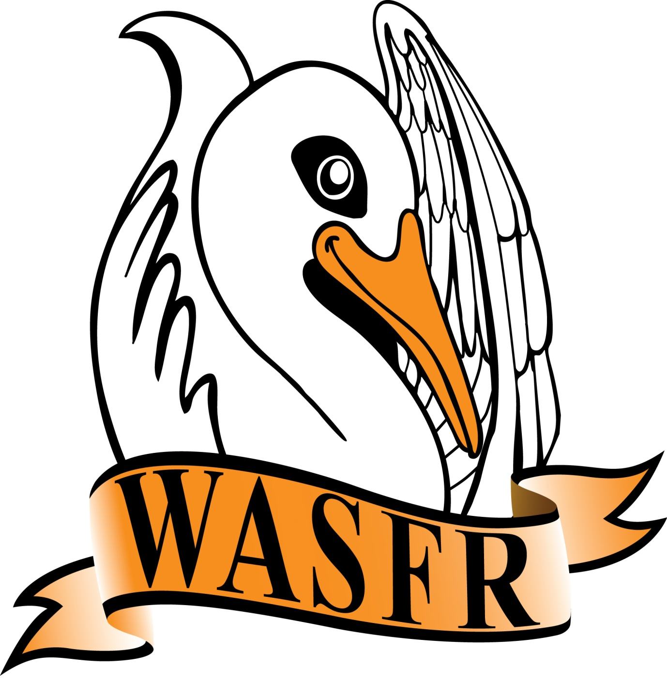 MINUTES - AGM
Minutes of the thirteenth Annual General Meeting of WASFR Inc. held at the Cambridge Bowling Club, Howtree Place, Floreat, on Friday 12 AUGUST 2022.

The President opened the meeting at 10.05 am and welcomed all those present (25 members and 15 visitors). He explained that this AGM is to be immediately followed by a short General Meeting with the guest speaker scheduled to commence around 11am. The guest speaker originally scheduled for today is held up in the UK (due to flight problems), but we have been very fortunate in obtaining the services of Mr. Chris Douglas who will talk on “Big Companies and how they Avoid Tax”. We will attempt to get through the necessary issues as quickly as possible.
APOLOGIES:
V. Payne, E. & S. Goodchild, N. Karpewycz, J. Yeatman, M. Harris, R. & J. Dawson, J. & H. Howard and S. Black.

CONFIRMATION OF MINUTES:
Moved R. Wyatt, seconded T. Bailey, that the Minutes of the previous Annual General Meeting held on 13 August 2021, be accepted as a true record. Carried.
There was no specific business arising that couldn’t be dealt with in the following General meeting.

PRESIDENT’S REPORT:
The President read out his report covering the activities of WA Self Funded Retirees Inc. over the past 12 months - copies are available to members. (a copy is attached to these Minutes).

TREASURER’S REPORT:
In the absence of the Treasurer, the President referred members to the Treasurer’s report that had been circulated amongst members. On the reverse of this report there is a statement from the Treasurer explaining some of the details involved. There was a Loss of $429.72 last year which was, primarily, due to the purchase of a new laptop computer ($1,213.60). The costs involved in the Investors Group meetings also were additional to those involved in past years. Total equity, as at 30 June 2022, amounted to $6,823.30. The PA system, old laptop computer, projector, printer, sandwich board and the kettle have all been completely written off. Rent has been paid up to the end of the year. A comment was made that, in future, any costs relating to “Out of pocket expenses to Committee members” that are in excess of $500 should be itemised. No further questions from members.
Moved P. Farr, seconded T. Bailey, that the Treasurer’s report be accepted. Carried.

ELECTION OF OFFICE BEARERS:
The President advised that, in accordance with Clause 9.6.1 of the Constitution, the Committee had appointed Mr. R. Wyatt to act as the Returning Officer for the purpose of conducting an election of Office Bearers for the 2022/23 year.
Mr. Wyatt then took the Chair and asked the meeting if there were any late nominations for positions of President, Vice President, Secretary and Treasurer, together with several Committee members. As there
were no further nominations, and that only one nomination had been received for the positions of
President, Secretary and Treasurer, then the following members are duly appointed as follows

State & Federal Advocates for Fully and Partly Self Funded Retirees cont. over

President: Mr. R. de Gruchy
Secretary: M/s S. Goodchild
Treasurer: M/s M. Harris
Note: There was no nomination for the position of Vice President.
The Committee would consider any action necessary to fill this position

There were 4 nominations for positions of Committee members, as follows
M/s M. Cresswell Mr. J. McPhail,
Mr. P. Farr,
Mr. B. Ellis
who were duly appointed as Committee members.

GENERAL BUSINESS:
R. de Gruchy resumed the Chair and thanked all those present for their support. He repeated an earlier comment that we still need people to volunteer for a position on the Committee. Whilst we have the essentials for a working Committee, there is no capacity to cover any unforeseen issues that can arise through holidays, or sickness.
Members were then asked if there were any particular matters arising from the Minutes of the 2021 AGM that they wished to discuss before closing this meeting and moving on to the General Meeting. As no such matters were raised, the President closed the meeting at 10.25am.

Confirmed ...............................

Date ........................................

WASFR Inc. does not give advice on any personal, or financial, matters.
Nothing written or spoken in the course of WASFR meetings, talks or publications,
is to be construed as advice given to members.

State & Federal Advocates for Fully and Partly Self Funded Retirees

