WESTERN AUSTRALIA SELF FUNDED RETIREES Inc.
wasfrinc@gmail.com
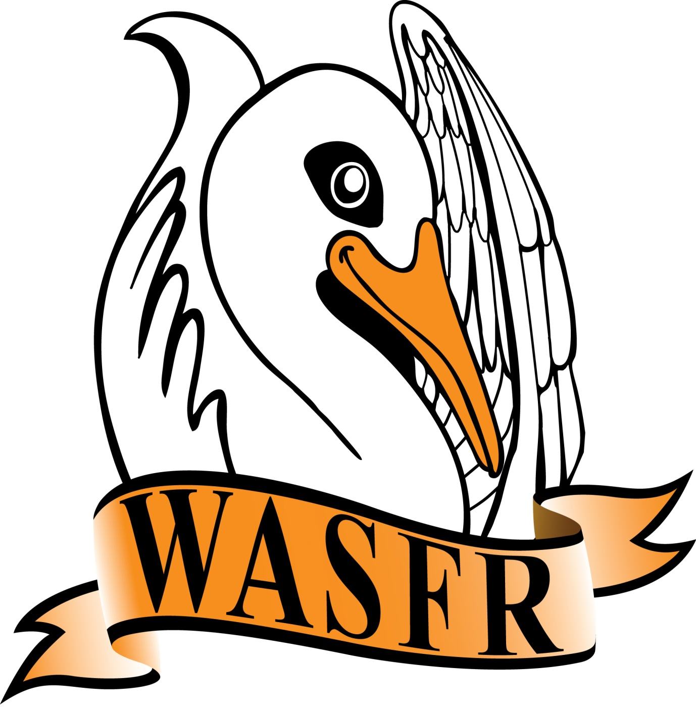 MINUTES - AGM
Minutes of the twelth Annual General Meeting of WASFR Inc. held at the Cambridge Bowling Club, Howtree Place, Floreat, on Friday 13 AUGUST 2021.

The President opened the meeting at 10.05 am and welcomed all those present ( members and visitors). He explained that this AGM is to be immediately followed by a short General Meeting with the guest speaker scheduled to commence around 11am - we will attempt to get through the necessary issues as quickly as possible.
APOLOGIES:
N. Karpewycz, R. Bannerman, P. Ellery and S. Dewar.

CONFIRMATION OF MINUTES:
Moved J. Yeatman, seconded B. Arnold, that the Minutes of the previous Annual General Meeting held on 14 August 2020, be accepted as a true record. Carried.
There was no specific business arising that couldn’t be dealt with in the following General meeting.

PRESIDENT’S REPORT:
The President read out his report covering the activities of WA Self Funded Retirees Inc. over the past 12 months - copies are available to members. (a copy is attached to these Minutes).

TREASURER’S REPORT:
Copies of the Treasurer’s report had been circulated amongst members. Total equity, as at 30 June 2021, amounted to $7,253.02. The PA system, laptop computer, projector, printer, sandwich board and the kettle have all been completely written off. Rent has been paid up to the end of the year. The Treasurer explained that this year actually showed a Gain of $1,070.13 (despite the Total Equity being less than the previous year - due to some subs. being paid in advance etc.). Questions were invited from members - none forthcoming. Moved M. Harris, seconded P. Farr, that the Treasurer’s report be accepted. Carried.

ELECTION OF OFFICE BEARERS:
The President advised that, in accordance with Clause 9.6.1 of the Constitution, the Committee had appointed Mr. R. Dawson to act as the Returning Officer for the purpose of conducting an election of Office Bearers for the 2021/22 year.
Mr. Dawson then took the Chair and asked the meeting if there were any late nominations for positions of President, Vice President, Secretary and Treasurer, together with several Committee members. As there
were no further nominations, and that only one nomination had been received for the positions of
President, Secretary and Treasurer, then the following members are duly appointed as follows

President: Mr. R. de Gruchy
Secretary: M/s S. Goodchild
Treasurer: M/s M. Harris
Note: There was no nomination for the position of Vice President.
The Committee would consider any action necessary to fill this position.

State & Federal Advocates for Fully and Partly Self Funded Retirees cont. over

There were 4 nominations for positions of Committee members, as follows
M/s M. Cresswell Mr. J. McPhail,
Mr. P. Farr,
Mr. J. Yeatman
who were duly appointed as Committee members.

GENERAL BUSINESS:
R. de Gruchy resumed the Chair and thanked all those present for their support. He repeated an earlier comment that we still need people to volunteer for a position on the Committee. Whilst we have the essentials for a working Committee, there is no capacity to cover any unforeseen issues that can arise through holidays, or sickness.

Life Membership:
The President said that the Committee had decided to nominate 3 long serving members as Honorary Life Members - M/s M. Harris, M/s P. Ellis and M/s V. Payne. Unfortunately M/s P. Ellis had passed away only 3 days prior to the meeting so a presentation of a Life Membership certificate had been made to her on 28th July at her home in Floreat. The funeral is scheduled for 10am on Friday 20th August at Pinnaroo Cemetery - 10 people signified their intention to attend the funeral.
M/s M. Harris has been the backbone of this organisation ever since it was founded. Both as the Editor of WASFR News, Treasurer, and staunch member of the Committee she has always been ready to take on other duties (including compiling summaries of guest speakers when required). Officially nominated by the President, seconded by I. Moller, the nomination was carried unanimously. After presentation of a certificate of Honorary Life Membership M/s Harris thanked everyone present for the award.
M/s V. Payne has also been a strong member of the Committee right from the beginning. Vera had accepted the arduous role of arranging guest speakers - in addition to the task of providing summaries of their presentations for inclusion in WASFR News. Many other duties involved in being a Committee member of this organisation were willing accepted. Nominated by the President, seconded by J. Yeatman, the nomination was carried unanimously. After accepting the certificate of Honorary Life Membership Vera thanked everyone for their support adding that she had enjoyed her time on the Committee and encouraged others to consider serving on the Committee.

Members were then asked if there were any particular matters arising from the Minutes of the 2020 AGM that they wished to discuss before closing this meeting and moving on to the General Meeting. As no such matters were raised, the President closed the meeting at 10.25am.

Confirmed ...............................

Date ........................................

WASFR Inc. does not give advice on any personal, or financial, matters.
Nothing written or spoken in the course of WASFR meetings, talks or publications,
is to be construed as advice given to members.

State & Federal Advocates for Fully and Partly Self Funded Retirees

