WESTERN AUSTRALIA SELF FUNDED RETIREES Inc.
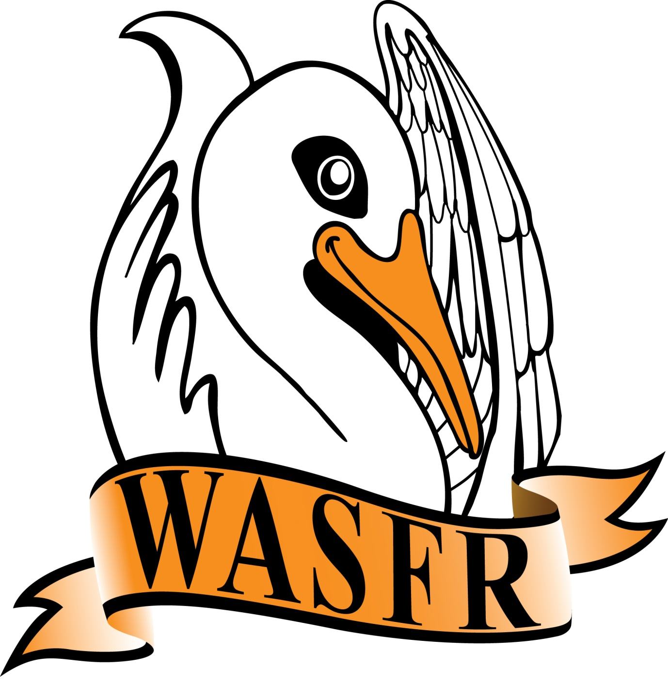
PRESIDENT’S REPORT - AGM 11 August 2023
It is now 13 years since we broke away from A.I.R. and created the WA Self Funded Retirees organisation. The time seems to have passed very quickly.
During this period of time there have been several changes of government, both State and Federal, and some interesting issues have evolved.
In 2009 the Rudd Labor government reduced the Age pension Taper rate and so allowed many self-funded retirees to apply for a part Age pension. However, when the limit on assets exceeded $1.16 million dollars, it was obvious that this was not going to last forever. In 2016 Joe Hockey announced “THE AGE OF ENTITLEMENT IS OVER” and he then proceeded to increase the Taper rate to $3 per $1,000 and, accordingly, over 300,000 part Age pensioners were taken off the Age pension.
The Assets limit was reduced to $816,000 as from 1 January 2017 - but has now increased to $986,500 ($656,500 for a single) should we start to think about another reduction once this limit increases to more than $1 million ??
Another interesting issue is the increases in the Commonwealth Seniors Health Card. In 2001 it was increased to $50,000 single and $80,000 for a couple. Despite continued pressure from several organisations it remained static for 14 years when CPI increases were finally approved. Then, prior to last years Federal election, the then Prime Minister decided to apply a 60% increase to the CSHC limits - which the Labor Party agreed to implement if they won the election. Obviously this was warmly welcomed by many retirees !!
Another pre-election decision was the Stage 3 tax cuts due to commence in July next year. At this point in time there has been no indication from the government that will change - however, it is possible that there could be a deferment to a later date ???
We have continued to lodge joint submissions to both the State and Federal governments, but with little success. This situation can be partly attributed to the poor financial state of Federal finances over the past 15 years and, possibly, the COVID crisis over the past 3 years. The recent Federal Budget surplus must be seen as a once-off and should not be regarded as continuing. Indeed, the Treasurer has indicated that he intends to allocate part of this surplus to reducing the enormous amount of debt that this country has accumulated - most people would agree that this is a sound decision.
One thing we have noticed is that it has become increasingly difficult to get to speak personally with Federal Ministers - we have to accept speaking with their advisers - which is not the same. The new TEAL politicians, however, are accessible on most occasions.
The final report from the Royal Commission into Aged Care Quality and Safety was handed in to the government in February 2021 with 148 recommendations. The COUNCIL OF ELDERS was created in December 2021 and their term of office finishes in December this year. Nominations have been invited for the next 2 yrs
In June this year the government announced the creation of an AGED CARE TASKFORCE headed by the Minister for Aged Care. This Taskforce is required to present an interim report in October with their final report due in December this year. The main focus for this Taskforce is how to handle the increasing costs for Aged Care - possible increases in the Medicare Levy, but also increasing compliance on the “USER PAYS” principle.
We continue to maintain contact with Gold Coast Retirees, Brisbane North Retirees, Public Sector Superannuants (based in South Australia), as well as the Association of Independent Retirees (A.I.R.) Ltd. - both here in WA as well as nationally. We are also in touch with COTA Australia, and National Seniors Australia, on a regular basis.
On a State level we continue to be involved with the WA Seniors Alliance which consists of 7 different organisations. On the plus side we have welcomed the AGED CARE REFORM NOW group in WA as members who are very active in their field of Aged Care and affiliated problems.
Finally, may I thank all the Committee members, in particular Margaret Harris and Sharon Goodchild, for their continued support throughout the year. May I also give thanks to Edward Goodchild who has put in a tremendous amount of work in getting our website up-to-date, together with his continued summaries of the talks given by our guest speakers - we would be lost without him.
Thank you all for putting up with me for another year.

Ron de Gruchy
11 August 2023

