WESTERN AUSTRALIA SELF FUNDED RETIREES Inc.
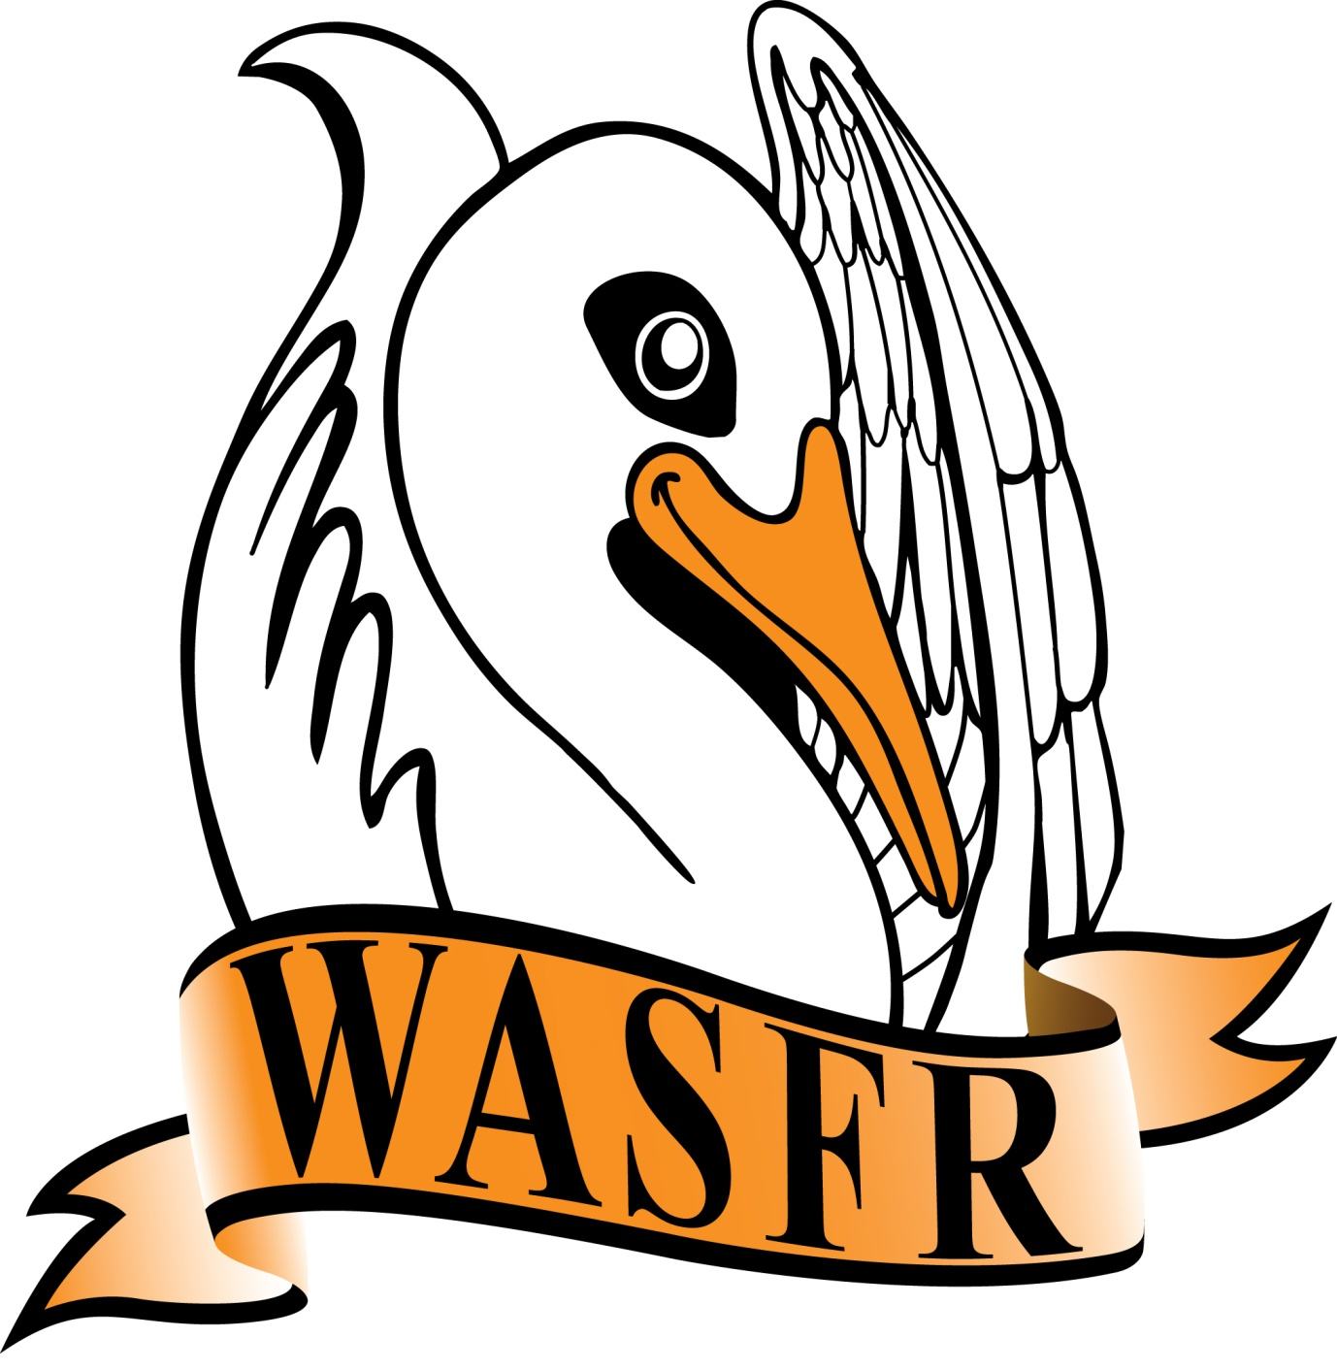
PRESIDENT’S REPORT - AGM 12 August 2022
We have a busy programme this morning so I will keep this as brief as possible. Several matters have been quite newsworthy over the past 12 months but the War in Ukraine, the continuation of this Covid pandemic and the formation of a new Federal government are up there at the top. Of course, there have been traumatic floods, bushfires, storms, plus the death of two well known ladies that have also made the headlines.
The large losses suffered by the Liberals at the Federal election were of a surprise to many of us. Many people had predicted a Labor victory - but not to the level that eventuated.
The new Labor government has only been in office less than 3 months, but they have already set the pattern of trying to get some election promises become fact.
As you know, there is a Federal Budget due out in October and we lodged our submission several weeks ago. There are a few copies of this submission available here but it might be easier if we sent you an email copy - please hand over your email details to Margaret, or myself, at the tea-break.
It has been difficult trying to arrange meetings with these new Ministers as they all seem to be very busy coming to grips with their new responsibilities - we can only hope that they become available sometime before the Budget comes out in October ? We have met with the Member for Moore, Ian Goodenough, and we met with the new Member for Curtin a few weeks ago. We have a tentative date to meet with Senator Dean Smith in 2 weeks time.
The Review into Retirement Incomes was released to the public at the end of 2020 but we have yet to see any serious changes to the current situation. As you are aware, there were no actual recommendations - just observations.
The Royal Commission into Aged Care Quality and Safety was handed in to the government in March last year with 148 recommendations. The government is slowly working their way through these recommendations with the creation of the COUNCIL OF ELDERS being something that does seem like a positive move. This COUNCIL OF ELDERS will remain in force till December next year - but I expect we will see some sort of initial report before then.
We continue to maintain contact with Gold Coast Retirees, Brisbane North Retirees, Public Sector Superannuants (based in South Australia), as well as the Association of Independent Retirees (A.I.R.) Ltd. - both here in WA as well as nationally.
On a State level we continue to be involved with the WA Seniors Alliance which consists of 7 different organisations. Unfortunately, although one of the founding members, National Seniors are not able to provide a representative at this time. On the plus side we have welcomed the AGED CARE REFORM NOW group in WA as members and we look forward to work with them.
Finally, may I thank all the Committee members for their continued support throughout the year. It has been said before, but we do need more members to step up and become a part of the Committee - we can’t expect the current members to be there forever. We have now been active for 12 years since we broke away from A.I.R. in 2010 and became more independent. Let’s hope we can continue to keep going in the same manner for another 12 years.

Ron de Gruchy
12 August 2022

