
WA Seniors Alliance

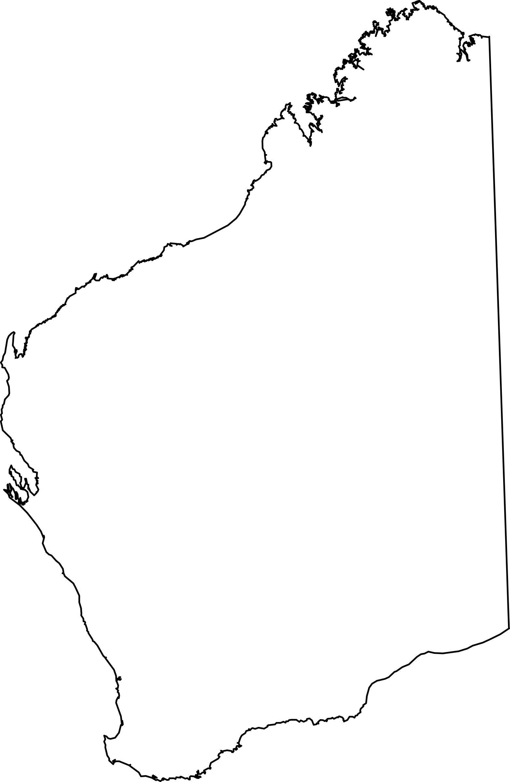
Submission to WA State Government

June 2025



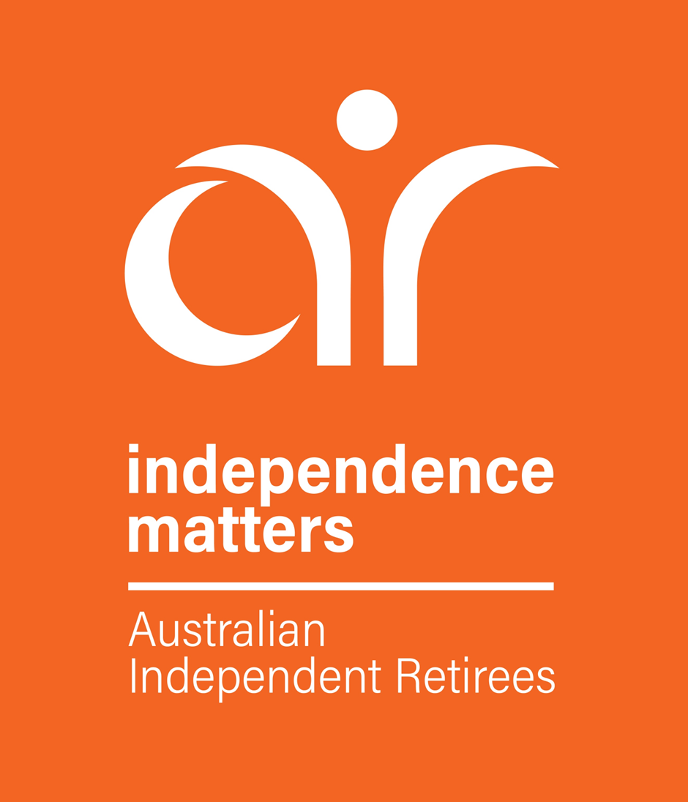

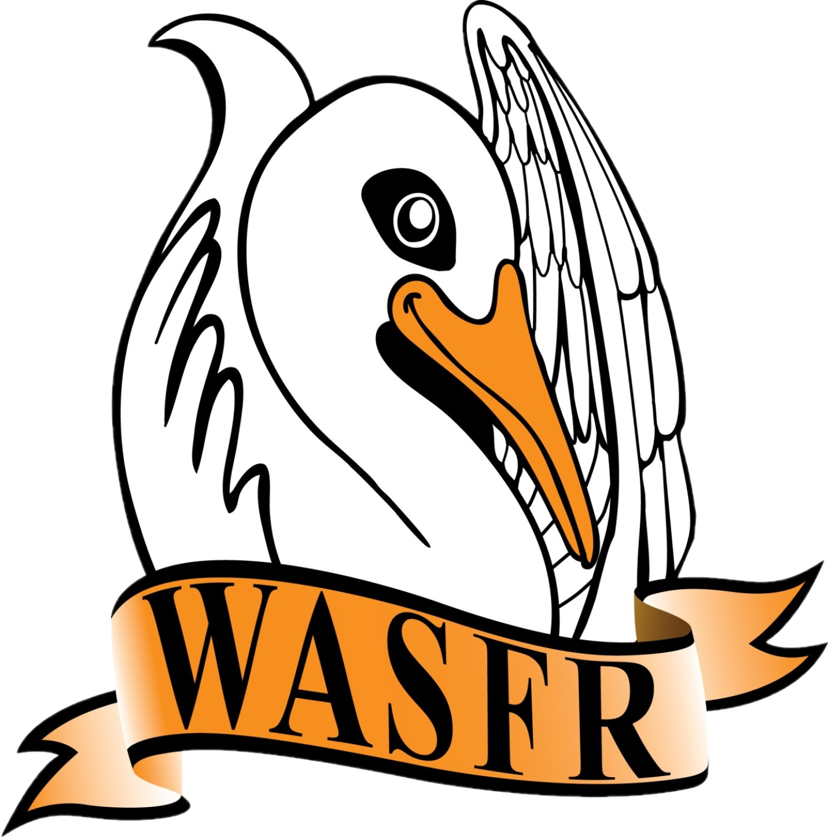


BACKGROUND

The WA Seniors Alliance was formed in February 2018. It was originally known as the WA Seniors Consultative Forum which was formed in August 2008 following a meeting of like-minded Seniors organisations, who have a common interest to protect their living standards from both State and Federal Governments. The intention in forming this group was to be able to provide a focused approach on Seniors’ interests. In many cases, each of the nominated Seniors’ organisations have a particular emphasis placed on certain issues that may be confined to those members of that particular organisation. This is a fact that cannot be denied. However, it is also true that there are several issues that are common to each and every Seniors’ organisation. It is on these particular issues that this submission is focused.

It is worth repeating that similar bodies exist in several other States in Australia. There is an obvious benefit in various organisations all joining together to make a consolidated approach to Governments.

The organisations involved in this group are

Aged Care Reform Now (ACRN)
Australian Independent Retirees (A.I.R) Limited (AIR)
Naval Association (WA Branch) (Navy)
Returned & Services League of Australia WA Branch Inc. (RSLWA)
Superannuated Commonwealth Officers’ Association WA Inc. (SCOAWA)
Western Australia Self Funded Retirees Inc. (WASFR)

For enquiries contact:
R. de Gruchy
phone: 9447 1313
email: rdegruchy@bigpond.com

10 June 2025
page 2

SUMMARY OF RECOMMENDATIONS

A summary of the recommendations in this submission from the WA Seniors Alliance is set out below. We ask for your support in consideration of these issues.

RECOMMENDATION No. 1
That consideration be given to the (once only) concession of Stamp Duty, the same as available to First Homeowners, on the purchase of a place of residence by a Senior, who has reached pensionable age, and is in possession of either one of the Pensioner Concession Cards, a Commonwealth Seniors Health Card or a Department of Veterans Affairs Gold Card.

RECOMMENDATION No. 2
That additional funding be provided for extending the Oral Health program for Seniors in possession of a WA State Seniors Card, providing general services on a regular basis. Such additional funding should also recognise the problems faced by seniors living in regional and remote WA.

RECOMMENDATION No. 3
That a review of Land Tax collections in WA be carried out with the intention being to abolish the policy of aggregation of the values of different parcels of land when calculating the rate of Land Tax that is to be paid. Such review to be limited to those WA residents in possession of a WA State Seniors card, one of the Pensioner Concession Cards, a Commonwealth Seniors Health Card or a Department of Veterans Affairs Gold Card.

RECOMMENDATION No. 4
That a minimum increase of 10% (to $825 and $660), be immediately applied to the
current caps on Local Government Council Rates and Water Rates and that steps are
taken to introduce yearly increases based on future increases in the CPI.

page 3

RECOMMENDATION No. 1
CONCESSION OF STAMP DUTY

Following retirement, and the consequent significant change of lifestyle, many Seniors find it
desirable, or necessary, to depart from the family home and obtain alternative accommodation
This may, possibly, be closer to medical and hospital services, and may also be more suited
to their changed physical circumstances and lifestyle. To assist this process, we request a
concession of Stamp Duty, following the sale of the family home and the purchase of
alternative accommodation, by a Senior, provided
- The Senior is of, or above, “pensionable age”, and
- Is only applicable to one dwelling, and
- Is a once-only concession, and
- Is limited to those retirees in possession of a Commonwealth Seniors’ Health Card
(CSHC), one of the Pensioner Concession Cards (PCC) or a Dept. of Veterans Affairs
Gold Card, and
- The value of the concession being sought is the same as the First Home Owners
concession - as amended from time to time.
Note: The States of Victoria and the NT have all introduced a similar concession for
Seniors in the past 8 years.
RATIONALE
- Beneficial to support agencies with increased numbers of older people residing in more
contained residential groups/areas.
- Increases the number of larger homes on the market in suburbs with established
infrastructure which, otherwise, would not be offered for sale.
- Potential to increase revenue to Government over time as more high value homes would
be in the market attracting the payment of increased Stamp Duty.
- Creates development/employment/retirement/construction opportunities and impacts
favourably upon associated entities/business and material suppliers etc.
- Is consistent with the policy precedent of abolishing Stamp Duty for the first home buyers
(normal limits apply).

RECOMMENDATION We recommend that consideration be given to the conditional concession of Stamp Duty on the purchase of a place of residence by a Senior, who has reached pensionable age, and is in possession of either one of the Pensioner Concession Cards, a Commonwealth Seniors Health Card or a Dept. of Veterans Affairs Gold Card.
page 4

RECOMMENDATION No. 2
ORAL HEALTH PROGRAM FOR SENIORS
There is no argument that accessibility to Dental services is an important issue for older people.
Improving access to oral health services is crucial to maintaining the overall health and well-
being for this group. Indeed, the State Oral Health Plan 2016-20 recognises frail older people
as a priority group and that improving the access to Dental services is an issue for older West
Australians.
Oral health issues are strongly linked to a person's general health, and, if left untreated, can
often result in social isolation which can lead to both mental, and physical, illnesses. Poor oral
health is also linked to chronic diseases, including stroke and cardiovascular disease together
with coronary heart risk, rheumatoid arthritis and diabetes mellitus.
Preventable dental conditions that are being treated in hospitals are putting added strain on
emergency departments, as well as on the State health budget. The number of potentially
preventable hospitalisations due to dental conditions in WA is around 10,000 each year and
WA has the second highest proportion of potentially preventable hospitalisations due to dental
conditions nationally.
The WA Government provides eligible concession card holders with subsidised treatment
through the Oral Health Centre. However, the demand for these services far outstrips supply
and for those without private health insurance the treatment can be a considerable cost. There
is little direct control of fees charged by private dentists. High costs create treatment barriers
for many seniors.
The Country Patient's Dental Subsidy Scheme allows persons eligible for public dental services
who live in an area where there are no public dental clinics, to access care through private
dental services at a subsidised rate. Unfortunately, this scheme is not available to older West
Australians who are housebound, or require ambulance transport to a dental care service due
to some form of disability.

In order to support the oral health care of older Western Australians and enhance quality of life
funding should be specifically allocated for older people living in residential aged care and for
those receiving in-home care.

RECOMMENDATION
That additional funding be provided for extending the Oral Health program for seniors in
possession of a WA State Seniors Card, providing general services on a regular basis.
Such additional funding should also recognise the problems faced by seniors living in
regional and remote Western Australia.

page 5

RECOMMENDATION No. 3

REVIEW OF LAND TAX COLLECTIONS

The matter of Land Tax has several components that are of concern to all WA citizens, including
many seniors/retirees who have structured their retirement income on property investments, and in
doing so, become less of a burden on society. For many, the income they receive from their
investment properties is the main source of their income in retirement. The most contentious issue is
the policy of aggregating the values of all properties owned by an individual, which results in a higher
level of taxation for the Landowner.

The scales of assessing Land Tax go from
- Nil (to properties valued less than $300,000),
- to a flat rate of $300 for properties from $300,001 to $420,000, then,
- $300 plus 0.25 cents for each $1 in excess of $420,001 up to $1,000,000, then,
- $1,750 plus 0.90 cents for each $1 in excess of $1,000,001 up to $1,800,000, then,
- $8,950 plus 1.80 cents for each $1 in excess of $1,800,001 up to $5,000,000, then,
- $66,550 plus 2.00 cents for each $1 in excess of $5,000,001 up to $11,000,000, then,
- $186,550 plus 2.67 cents for each $1 in excess of $11,000,001.

Aggregation of Land Tax paid on multiple land holdings is placing an increasingly unacceptable burden
on retirees which they cannot continue to absorb. Some examples of this inequitable burden are
- Two investment properties averaging $550,000 each
- if Land Tax is assessed separately the total payable would be 2 X $625 = $1,250
- if Land Tax is aggregated the total payable would be $2,650
  - this is an increase of $1,400 - more than double
- Four investment properties averaging $550,000 each
- if Land Tax is assessed separately the total payable would be 4 X $625 = $2,500
- if Land Tax is aggregated the total payable would be $16,150
  - this is an increase of $13,650 - more than 6 times as much !

From the table above It is obvious that this policy of aggregating the totals of different land titles
results in a much higher level of taxation than if each land title was regarded as a separate issue.

It is considered that this policy of aggregation is most unfair, is inequitable and has no sound basis.
Our recommendation is that this matter be reviewed with the intention being to abolish the policy of
aggregation and consider each parcel of land as a separate entity, which is taxed accordingly.

RECOMMENDATION
That a review of Land Tax collections in WA be carried out with the intention being
to abolish the policy of aggregation of the values of different parcels of land when
calculating the rate of Land Tax that is to be paid. Such review to be limited to
those WA residents in possession of a WA State Seniors Card, one of the
Pensioner Concession Cards, a Commonwealth Seniors Health Card or a
Department of Veterans Affairs Gold Card.
page 6

RECOMMENDATION No. 4

INDEXATION OF LOCAL GOVERNMENT CONCESSIONS

In general, discounts available to Seniors residing in WA have been reasonably extensive but
the amounts appropriate to Local Government Council Rates, and Water Rates, have not been
changed for the last 9 years.

Prior to 2016 there was a full 50% discount available to Age pensioners, and to holders of the
Commonwealth Seniors Health Card (CSHC), on Council Rates and Water Rates. There was
a change made in the 2015/16 WA Budget that introduced a capping of $550 for Council
Rates, and $600 for Water Rates, as from 1 July 2016. After concerted pressure from
several retiree organisations the government relented and increased the capping on Council
Rates to $750 - no change to the capping of $600 on Water Rates.

Despite large increases in the cost of living there has been no changes to these caps of $750
and $600 In the past 9 years. Considering increases in the cost of living over the past 9 years
it is recommended that an increase of 10% is both fair and reasonable.

RECOMMENDATION
That a minimum increase of 10% (to $825 and $660), be immediately applied to the
current caps on Local Government Council Rates and Water Rates and that steps are
taken to introduce yearly increases based on future increases in the CPI.

page 7

